EE-281 Logic Design Lab

Lab #9

An asynchronous serial communication protocol implemented using the Spartan3

## Name: Ajin Sunny and Derek King

## Date of Experiment: April 13th, 2015

## Date of Completion of Report: April 27th, 2015

# **Introduction**

In this Lab we will learn about serial communication and attempt to send a three bit number between two Spartan3 boards. We are asked to write the serial communication code and simulate it. After the simulation confirms the validity of the code, we must built a receiver and sender board and connect them and send the three bit signal between the two. Additionally, we will implement a parity bit check that will help ensure the accuracy of the data being transmitted. Once the data has been received, the three bit binary number will be converted to decimal and displayed on one of the seven segment displays on the receiver board. In this lab, we will learn how to design a system that communicates serially. This is crucial to the field of computer engineering since so many protocols are designed serially, such as USB and Ethernet.

# **Experiment Description**

**Part 1**

In the first part of the experiment we first are required to design and write the code we will use to implement the serial transfer. For good design practice, and to make part two easier, we will design the sender and receiver separately in order to make implementing them on two separate boards much easier.

Below is the Verilog Code we used to implement the design, followed by a screenshot of the simulation:

Sender:

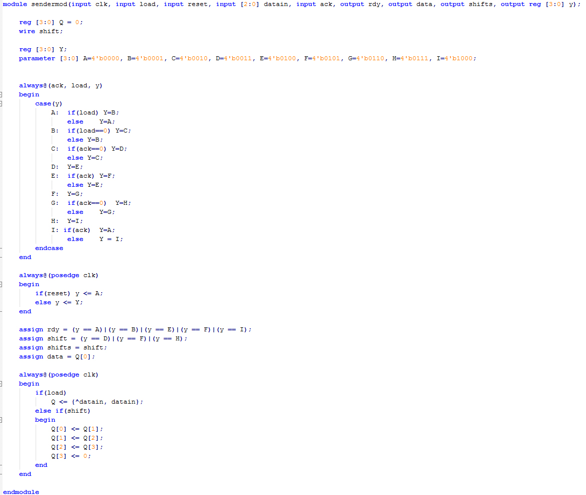

Receiver:

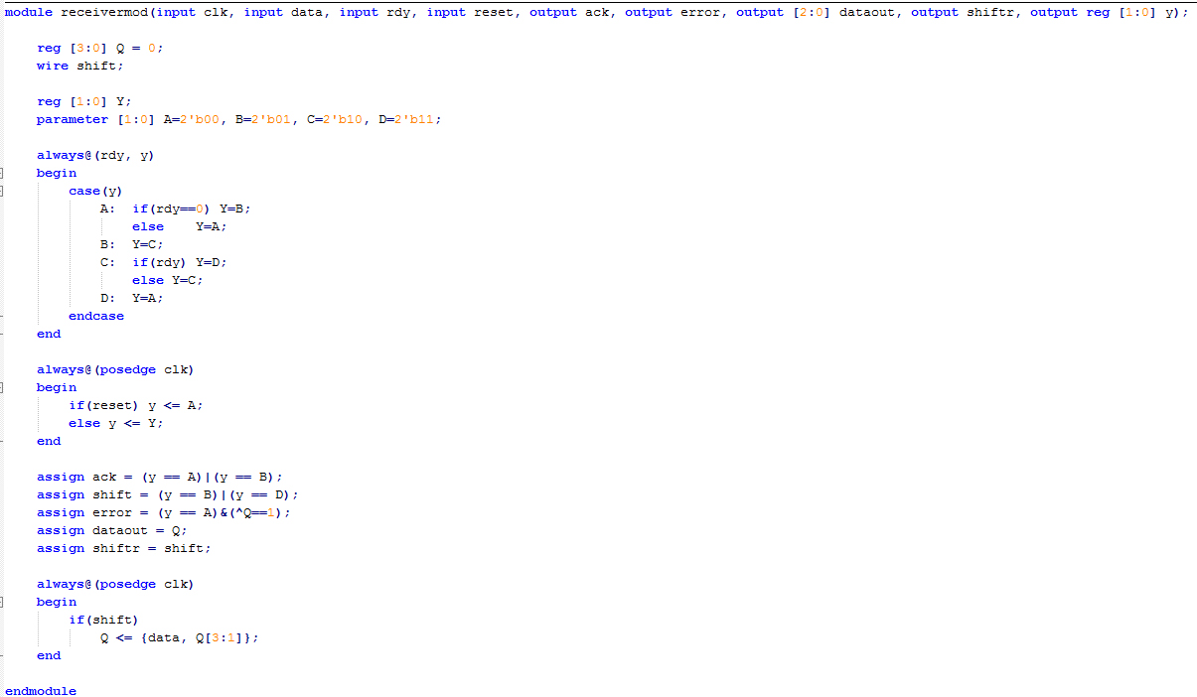

Top Module:

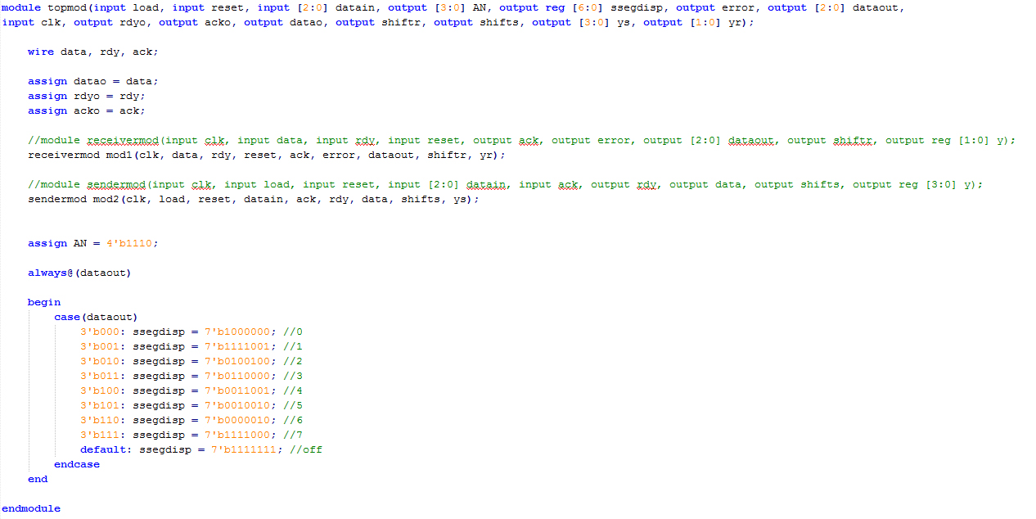

UCF:

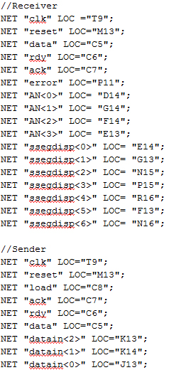

Simulation:

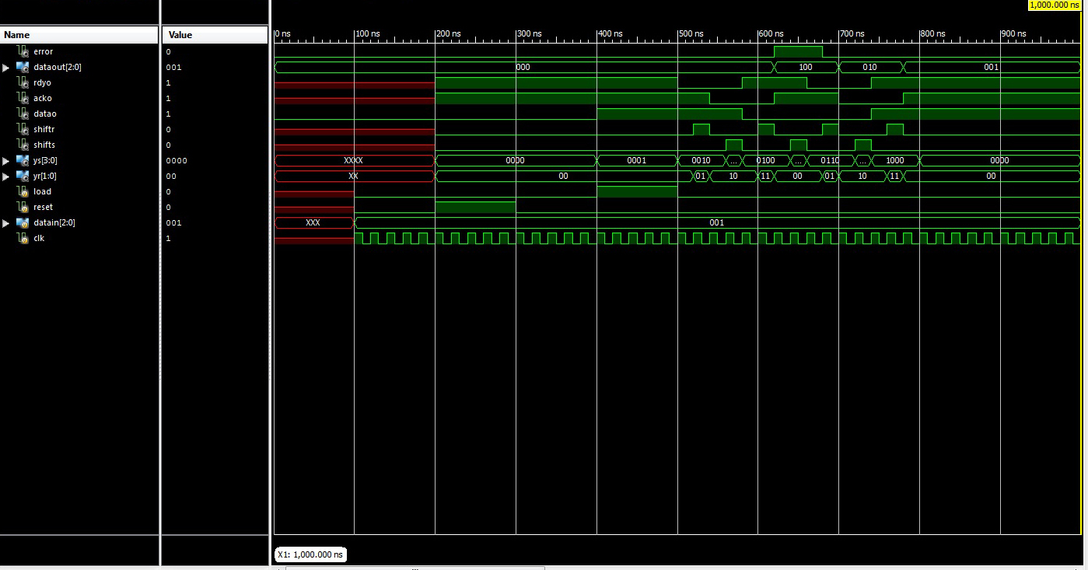

**Part 2**

In the second part of the experiment we wired the Spartan3 boards together, one programed with the sender Verilog code and the other with the receiver code. However, in this part, we were unsuccessful. We tried several different things, but we were unable to replicate the successful results from part one.

# **Results**

# **Conclusion**